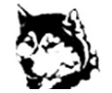

School Website: https://cns.nbed.ca/
Twitter: @cncs_huskies

Elementary School Supplies/Student Fees 2023-2024
Elementary students pay a $50 student/supplies fee in September. A portion of this fee is used to purchase school supplies for your child.

Please note: We encourage you not to send supplies from home as the fee will remain the same regardless.

We ask that you please pay this fee using School Cash Online, instead of sending cash or cheque with your child. Student fee payment will be available on School Cash Online near the end of August.

Please see the school website and click on the link to School Cash Online to register if you do not already have School Cash Online setup.

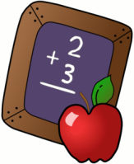
Elementary Students will need to bring:

1 pair of indoor sneakers – non marking
* Please label items with your child’s name
1 lunch bag
1 water bottle
1 backpack big enough to carry a 1” binder (binder will be supplied)
K-2 – please send in an emergency set of clothing in a plastic bag with your child’s name clearly marked on it.

