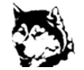
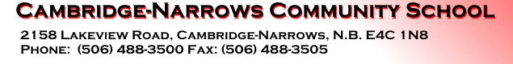

School Website: https://cns.nbed.ca/
Twitter: @cncs_huskies

Middle Level & High School
Student Fees 2023-2024
Middle Level and High School students pay a $40 student fee that is due in September. A portion of this fee is used for rental of locks and lockers, registration for school events and the purchase of some materials.

We ask that you please pay this fee using School Cash Online, instead of sending cash or cheque with your child. Student fee payment will be available on School Cash Online near the end of August, or first of September.

Please see the school website and click on the link to School Cash Online to register if you do not already have School Cash Online setup.

- Pack of Blue or Black pens
- 4 packs of 12 pencils
- White Out
- Pack of White Erasers
- 3 packs of 200 pages Loose leaf
- 2 packs of Graph Paper
- 1 pair of Scissors
- 12 pack of Crayola Markers
- 24 pack of Crayola Pencil Crayons
- Pencil Case

- Ruler
- Geometry Set
- Calculator (regular)
- Pack of Highlighters
- Sneakers/Clothing for Gym Class
- 2 – 3 ring binders with dividers:
- 2 Coil Hilroy Notebooks
- WATER BOTTLE (required as school has water bottle fill stations not drinking fountains)

