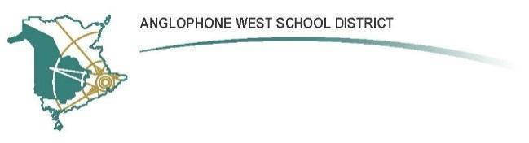

**Cambridge-Narrows Community School**

Address: 2158 Lakeview Road

Cambridge-Narrows, NB

E4C 1N8

**Parent School Support Committee**

**Meeting Minutes**

Date: October 19, 2023

Time: 6:00pm

Location: Teams Online

**Attendance:**

Sabrina, Heather TB, Heather B, Rebecca G, Sheila B, Stephanie C, Bethany K, Amber

Regrets: Emily & James Mills

**Call Meeting to Order 6:10**

**Additions to the Agenda -** introductions

**Approval of Agenda** Rebecca, Sheila

**New Business:**

1. **What is PSSC –** question about funding and how it’s distributed. It is about governance, we get funds for communication purposes. Small budget. Most money goes through home and school.
2. **Education Act –** Rebecca could not find this on Arcadia page, or the handbook. Sabrina will resend to everyone.
3. **PSSC Elections -** Chair: Sabrina Vice Chair: Amber Teakles Secretary: Emily, Rebecca if Emily isn’t available.
4. **Volunteer packages** – if you need one, get one from Sandra – everyone needs one.
5. **Meeting dates and times:** Third Thursday of the month at 6:30 pm – Sabrina will send the dates by email.
6. **Forms –** everyone has returned nomination forms, will give to Sandra; - what is the other form?
7. **Bussing update –** lots of publicity, on agenda for next 2 DEC meetings. He will let us know how it goes, Sabrina will keep us posted.
8. **Student fee incentive program update.** Home and School donated 300

**Principal Report:** - school profile says we are at 50% capacity. Do we need to start planning for expansion of the building, portables? Discussion of the history of the school, catchmentareas, Coles Island closing. 6 years ago we had 164 students; seems Covid has drawn people to rural community.

**Teacher Report**: Secondary team goal – to increase academic rigour. So far seeing lots of improvement, students like that they are held to high standard. Lots of guest speakers (Pogo, indigenous lead, football NB) – basketball season/tip off coming up; science east

Home & School Report: Rebecca – 2 meetings so far, open house went really well; student fee incentive. Bagel fundraiser will continue until Oct 23. Holiday Shopping Fundraiser Dec 11-12. More information to come. Safety week bus drivers – Ryan and Fred tied. 1 grant application to develop our sensory room.

**SRC Report:** Skylar is away – Oct 26 haunted walk at the pines ,looking for volunteers and white sheets. Leadership conference – 3 students attended. Dance went really well. Clothing orders due by Nov 2 Council of student leaders – Skylar will attend 4 meetings. Rebecca can likely get white sheets.

**DEC Report:** no report, James is at DEC meeting

**Next Meeting Date:** 6:30 pm (in-person) Nov 16

**Adjournment –** Sheila, Rebecca