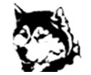

School Website: cns.nbed.nb.ca

X: @cncs_huskies

**Elementary School Supplies/Student Fees 2024-2025**

Elementary students pay a $50 student/supplies fee in September. A large portion of student fees goes toward purchasing school supplies for your child, which saves you time and money.

**Please note:** We encourage you **not** to send supplies from home as the fee will remain the same regardless.

We ask that you please pay this fee using School Cash Online, instead of sending cash or cheque with your child. Student fee payment will be available on School Cash Online near the end of August. If you need to make payment arrangements, please contact the school.

There is a link on our school website for School Cash Online, where you can register if you do not already have School Cash Online setup. This is quick and secure.

Elementary Students will need to bring:

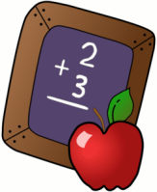

1 pair of indoor sneakers – **non marking**

1 lunch bag

1 backpack big enough to carry a 1” binder (binder will be supplied)

***WATER BOTTLE (required as school has water bottle fill stations not drinking fountains)***

***UTENSILS (we do not provide)***

**K-2** – **please send in an emergency set of clothing in a plastic bag with your child’s name on it.**